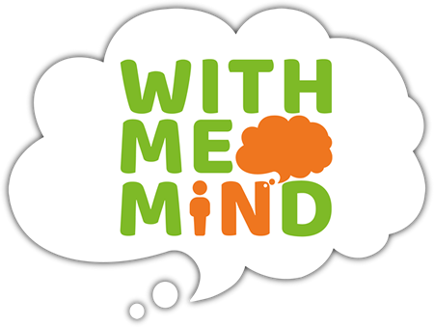

With Me in Mind – information gathering.
Name of school & person sharing concern:

Name of Pupil, address and Date of birth:

Consent gained from parent? Name and contact number.

Consent from child- would they like support?

Date of Birth:

Please give as much detail as possible.
What other services and interventions are/have been involved?

Are there any risks? (to themselves, to others or from others)

What are the main concerns for the young person? What are their concerns?

What do you think the problem is? Where does the problem occur? Does anything make the problem better or worse? Are concerns shared with anyone else? How long has this been going on for?

What is going well?
Strengths/positive, hobbies, support that has been useful? Friendships?

Family structure

Who does the young person live with? Any social factors that may be impacting? Change in relationships? New baby? New partner?

Life events

(Has the young person experienced any trauma? Domestic violence? Bereavement? Home moves? Parental mental illness? Physical illness or developmental delay?
Any other relevant information.

What would you/parent/child like to achieve from our support?

